Work Package 2.2.1

Participant CFw Briefing

Vehicle Interaction Control Improvement Project

|  |  |
| --- | --- |
| WBS Parent | 2. VI Control Effectiveness (Phase 2) |
| WBS Reference | 2.2 VICE Baseline Validation Workshop |
| Work Package | 2.2.1 Participant CFw Briefing |
| Package Owner | Validation Workshop Facilitator |
| Owner Organisation | Your Company |
| Participants | Validation workshop participants made up of selected operations personnel, site and divisional HSE personnel, supported by experienced workshop facilitators for validation workshop. |
| Capability Required | Facilitators with CFw validation workshop experience. Cross sectional team with extensive site operations knowledge and experience.  Oversight by project manager, project team and senior operations personnel. |
| Description | Introduce workshop participants to the Control Framework Approach that they will apply to compare work as done with work as documented following this this iterative process:   * + - 1. Review the Required Operating State and confirm that it is relevant to safe and productive mobile equipment operations for this site       2. Review each Credible Failure Mode and confirm that the operational scenarios apply, and it can compromise the Required Operating State being reviewed       3. Then review each related Business Input to confirm that it can prevent or mitigate the Credible Failure Mode from compromising the Required Operating State.       4. Based on operational practice review and update ‘work as documented’ details on how the Business Input is:   1. Specified   2. Implemented and   3. Monitored |
| Completion State | **VICE Baseline Validation Workshop Participants are ready to review, update and validate the prepared Control Management Sheets.** |



**Process**

|  |  |
| --- | --- |
| **ACTIVITY** | **NOTES:** |
| Brief Senior Leaders on their role for project phases 1 and 2 and supporting the Validation Workshop covering:   * The ‘Company’ Vehicle Interaction Control  Improvement Strategy * Details of the Site Vehicle Interaction Control  Improvement Plan * An overview of the VI Control Improvement approach as a four phase Business Improvement Process that can linked to a broader company digital transformation strategy * Phase 1 VI Control mapping process and commitment * The timing and structure of the Phase 2 Validation Workshop and their involvement.   Suggestion: Brief senior managers using resources at the end pf this document   * Invitation Template for Phase 1 Site VICE Baseline allocated roles, and * Invitation Template for Phase 2 Validation Workshop participants | Project Manager  Invitation templates are included in this document. |
| **Welcome participants**   * Ask them to sign in * Point out tea and coffee areas.   Commence the workshop Welcome:   * Participant welcome by facilitator.   Opening:   * Workshop opening by senior manager (use invitation as a useful reference covering workshop intent) * Introduction of facilitators (capture their years in the industry). | Facilitator  Hang the starting set of A0 Control Sheets before the workshop begins.  Prepare your own facilitator Run Sheet and keep at hand. |

|  |  |  |
| --- | --- | --- |
| **Workshop Overview:**   * Provide an overview of ‘Company’ Vehicle Interaction Control Improvement project. * The intent of the workshop i.e. validation of the VI Control Effectiveness Baseline CFw before considering enhancements that may include technology controls. * Refer to the EMESRT Nine Layer Model of Control Effectiveness (see posters from references) * Provide an overview of the VI Control Baseline preparation work e.g. we reviewed 200+ documents and spoke to 20 people, it took us 4 weeks etc. * Say today’s session is about you ‘marking this homework.’   Participant Introductions:   * Ask each workshop participant to introduce themselves, model how you want it done covering:    + Their name   + Where they work and what they do   + Years in the industry (total these for all participants)   + Why effective control of vehicle interaction is important to them * Capture key points from each introduction.   Total up the participant years and say you are prepared to let them “mark your homework”. | | We suggest that you avoid using projectors during the workshop. |
| **Introduction to the Control Framework (CFw) Approach**   * Explain the hierarchical structure of a CFw:    + Required Operating States   + Credible Failure Modes   + Business inputs * Working from the butcher’s paper use a simple example e.g. ROS 06 – Physical barriers provide segregation (access control) that only has five (5) related failure modes to explain the concept | Flip chart explaining CFw structure – consider drawing it in real time.  A0 print-outs of ROS 06 – Physical Barriers (access control). |
| **Large group review of a control sheet:**   * Ask the large group to stand up and work together to review one of the simpler control sheets e.g.    + ROS 05 - Operators park vehicles in positions that avoid unwanted interactions   + ROS 09 - Loads are appropriate for vehicle type and site conditions, items are secured during travel.   + ROS 10 - Access Control - Vehicle operators limit movements / activities to designated areas. * Confirm that they understand the intent of the chosen ROS * First work down the Control Management Sheet and check that the Credible Failure modes are relevant, and if any are missing. * Work through the business inputs:   + Ask if that is how things work around here?   + Make edits with red pens.   + Beyond the edits, capture opportunities for improvement.   + Use post-it notes for further details.   **Confirm that participants understand the process.** | Use post-it notes to capture opportunities for improvement.  Encourage red marker pen mark-ups. |
| Preparing to move to Session 2:  Decide on make-up of small groups based on information provided during introductions and advice from site management.   * Ensure groups have a mix of skills and are balanced. * Ensure that each participant knows what small group they will be working in.   **End session 1 and go to a break.** | Ask participants to return at a  set time. |

**Figure 1: Vehicle Interaction Control Framework**

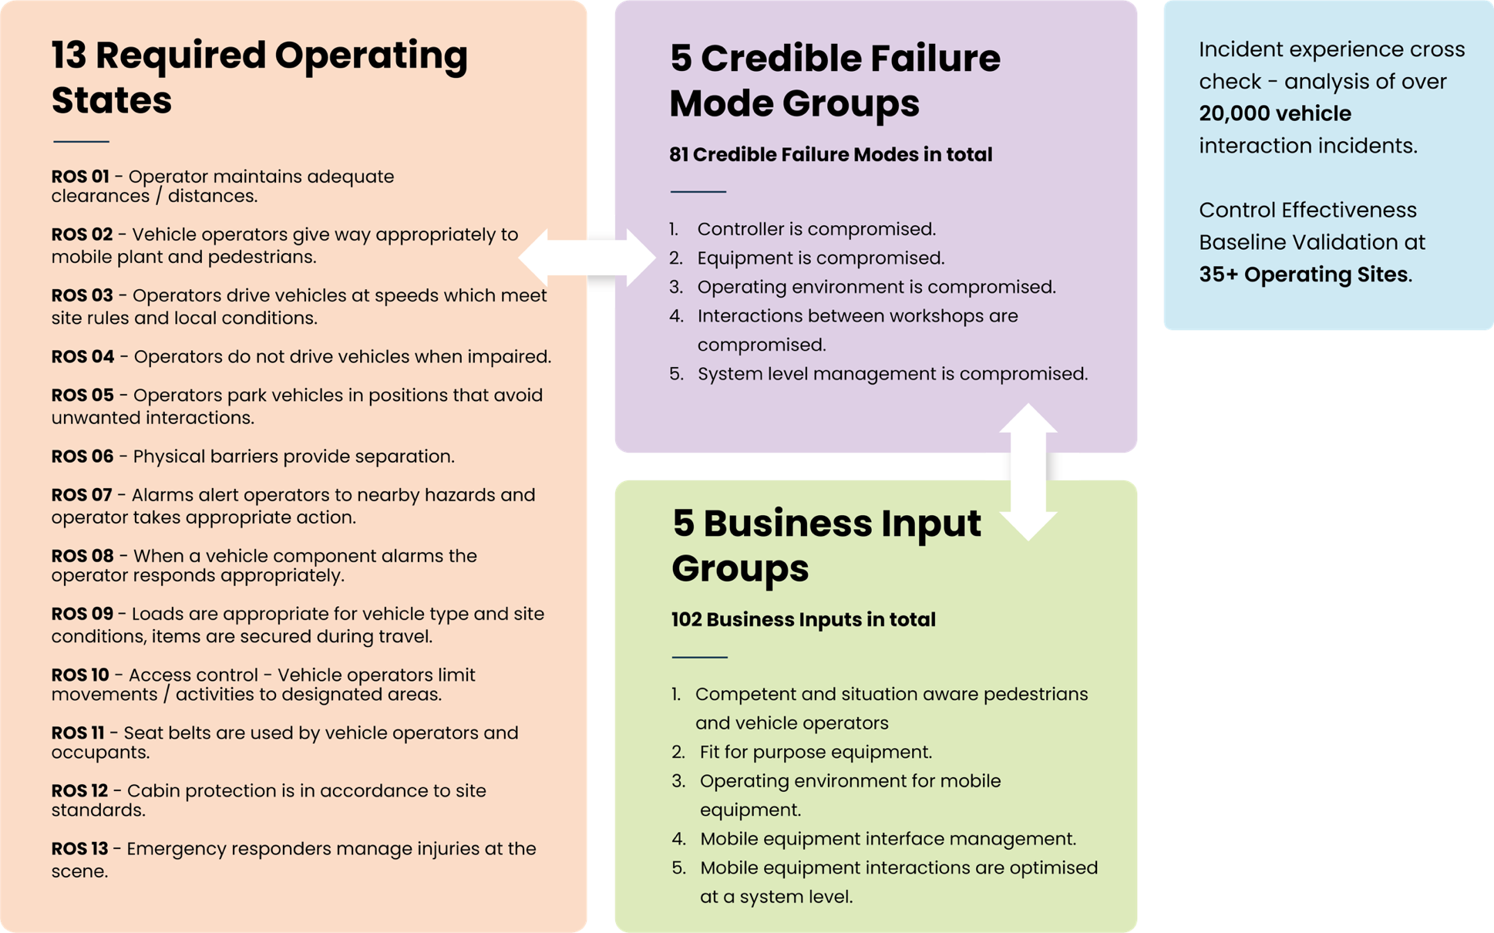

**References**

* [EMESRT VICI Facilitators Guide](http://www.emesrt.org/wp-content/uploads/FacilitatorGuide.pdf)
* [Control Management Sheets for the Site](http://www.emesrt.org/wp-content/uploads/VI_ControlManagementSheets.xlsx)

**Notes**

..............................................................................................................................................................

..............................................................................................................................................................

..............................................................................................................................................................

..............................................................................................................................................................

..............................................................................................................................................................

..............................................................................................................................................................

..............................................................................................................................................................

..............................................................................................................................................................

..............................................................................................................................................................

**Future recommendations and feedback**

..............................................................................................................................................................

..............................................................................................................................................................

..............................................................................................................................................................

..............................................................................................................................................................

..............................................................................................................................................................

..............................................................................................................................................................

..............................................................................................................................................................

..............................................................................................................................................................

..............................................................................................................................................................