Work Package PM.1.2

Project Charter

|  |  |
| --- | --- |
| **Vehicle Interaction Control Improvement Project** | |
| **WBS Parent** | PM. Project Management |
| **WBS Reference** | PM.1 Initiation |
| **Work Package** | PM.1.2 Project Charter |
| **Package Owner** | Project Sponsor – Senior Manager |
| **Owner Organisation** | Your Company |
| **Participants** | Project Manager, Senior Site and Divisional Managers |
| **Capability Required** | Senior management experience with financial authority |
| **Description** | The Project Charter is a document approved by the Project Sponsor that authorises the project and provides the Project Manager with the authority to apply organisational resources to project activities.  The Vehicle Interaction Control Improvement Project Charter should include the company intent and commitments for improving VI performance.  Where relevant, include site and divisional related information confirming that the planned work is part of a broader business improvement strategy work. |
| **Completion State** | **A Project Charter signed by the Project Sponsor, referencing the business case for the work, authorising the project, and providing authority to the Project Manager.** |
| **Description**  A project charter usually includes the following information:  **Project information:**   * Project name * Project Sponsor * Project Manager * Main stakeholders * Project team members * General project requirements   **Statement of Work (SOW):**   * Reference proposal (see next page...) | |

|  |
| --- |
| **Project activities**   * WBS results areas proposal table * Project schedule and major milestones * Initial project budget * Project constraints, assumptions, risks and dependencies * Project success criteria   **Project authorisation and approval documents**   * As required |
| **References**   * [Project Charter Template](https://emesrt.org/wp-content/uploads/Project-Charter-Template-V1.docx) * Company Vehicle Interaction Standards and Strategy * [EMESRT VICI Project Guide](https://emesrt.org/wp-content/uploads/EMESRT-VICI-Project-Guide-2023.pdf) * [PMBOK® Guide – Seventh Edition, Project Management Institute](https://www.pmi.org/pmbok-guide-standards/foundational/pmbok) |
| **Notes**  .....................................................................................................................................................................  .....................................................................................................................................................................  .....................................................................................................................................................................  ..................................................................................................................................................................... |
| .....................................................................................................................................................................  .....................................................................................................................................................................  .....................................................................................................................................................................  .....................................................................................................................................................................  **Future recommendations and feedback** |

.....................................................................................................................................................................

.....................................................................................................................................................................

.....................................................................................................................................................................

.....................................................................................................................................................................

.....................................................................................................................................................................

.....................................................................................................................................................................

.....................................................................................................................................................................

**Senior Manager Email project launch**

**Subject: [Site Name] – Vehicle Interaction Control Improvement Project Launch**

Colleagues

In our operations, vehicle interactions are constant: vehicle to pedestrian, vehicle to vehicle, vehicle to environment. While our current controls are generally reliable, our company level experience is that when they fail, then serious injuries and fatalities can occur.

[Company Name] has committed to systematically review the effectiveness of current vehicle interaction before the deployment of collision avoidance technology projects and is supporting [Site Name] to undertake this important work.

The [Site Name] Vehicle Interaction Control Improvement Project has these steps:

1. Align with the project team and appoint a site sponsor.
2. Prepare a ‘work as documented’ vehicle interaction control effectiveness (VICE) Baseline by asking senior personnel a series of questions that are directly relevant to their roles.
3. Carry out a Validation Workshop with a cross section of participants and use their experience to review, update and validate the Baseline to reflect ‘work as done.’
4. Use the Validation Workshop output to develop a plan (for senior manager review) that addresses any existing site vehicle interaction control gaps.
5. Apply and update the VICE Baseline as we introduce and operationally integrate Vehicle Interaction technology controls.

The work begins this week with a meeting that explains the project sequence and introduces project personnel. After the meeting, baseline mapping questions will be distributed to knowledgeable and experienced site personnel based on their role.

If you receive an email with questions attached, can you please aim to have your answers back by [add date]. As required you will be supported to answer the questions e.g. advice on referencing documents and describing processes.

Thank you for your assistance in this important work.

[Sign off by senior manager]

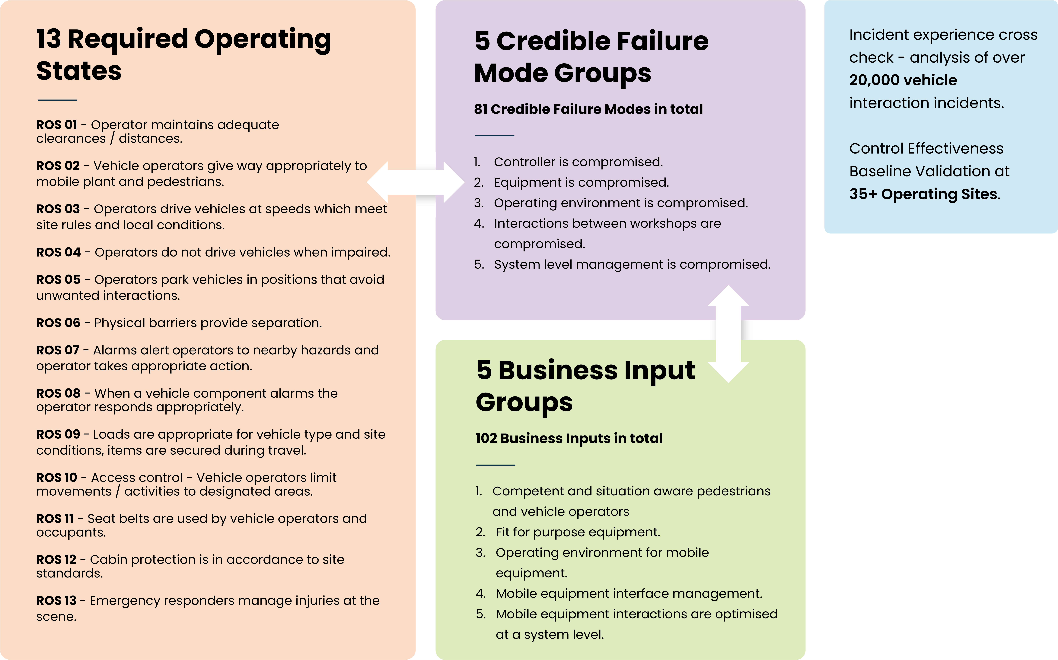

**VICE Baseline Validation Workshop – Participant Invitation**

|  |  |
| --- | --- |
| **Subject:** | Invitation Vehicle Interaction Control Effectiveness (VICE) Baseline Review Validation Workshop |
| **Date:** | Workshop – [add date] |
| **Time:** | Suggest local minimum 6 hours per day for 2 days |
| **Location:** | TBD |
| **Attendee distribution** | TBD |
| **Copy to Manager** | TBD |

Dear Colleague

As you know well, our business is committed to improving health and safety *[consider using reference from [Client] H&S policy]* and together we have an unambiguous intent to prevent fatalities and life-changing injuries in our workplace.

In our operations, mobile equipment interactions are constant: *vehicle to pedestrian, vehicle to vehicle, vehicle to environment.* While our current vehicle interaction controls are generally reliable, our company level experience is that when they erode or fail, then serious injuries and fatalities can occur.

For 2023, [Client] have committed to systematically review and improve vehicle interaction controls including reviewing the deployment of collision avoidance and fatigue monitoring technology.

[Mine site name] has been selected as the first site to begin this important project work. Based on your experience, knowledge, and role, you have been nominated to participate in a two-day workshop in [add month] that will:

* Provide you with an overview of the vehicle interaction control improvement project
* Confirm the importance of your honest and frank contribution
* Introduce the Vehicle Interaction Control Effectiveness (VICE) review approach
* Present a VICE baseline analysis of current [Mine site name] vehicle interaction controls
* Ask you to apply your skills and experience to review, correct and update the baseline analysis, so that it captures how we really operate
* As part of this review, we will work together to systematically identify any existing vehicle interaction control gaps and understand, why?
* From this baseline understanding, we will then prepare a plan to improve the reliability and performance of our vehicle interaction controls, including considering using technology
* Ask for your commitment to provide information, advice, and guidance to the project team over the life of the project.

Improving Vehicle Interaction controls is a complex project with multiple phases: understanding and improving existing controls, implementing new controls, assessing, and sourcing the best technology options, running pilots, managing production impacts, data collection and analysis etc.

However, the first and most important project step and workshop intent is to engage with knowledgeable and experienced people to confirm the project baseline and get their support for future work.

I look forward to working with you over the coming weeks.

Signed by

Site Manager

**Figure 2.2.1 a Overview of the Vehicle Interaction Control Improvement Project as Business Improvement Process**

